**Alarm SNS**

Step 1- Create alarm for CPU utilization. Make a instance then click on Alarm status.

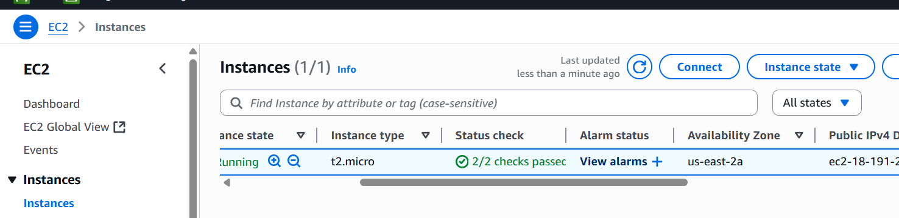

Create an alarm – put Create Alarm notification.

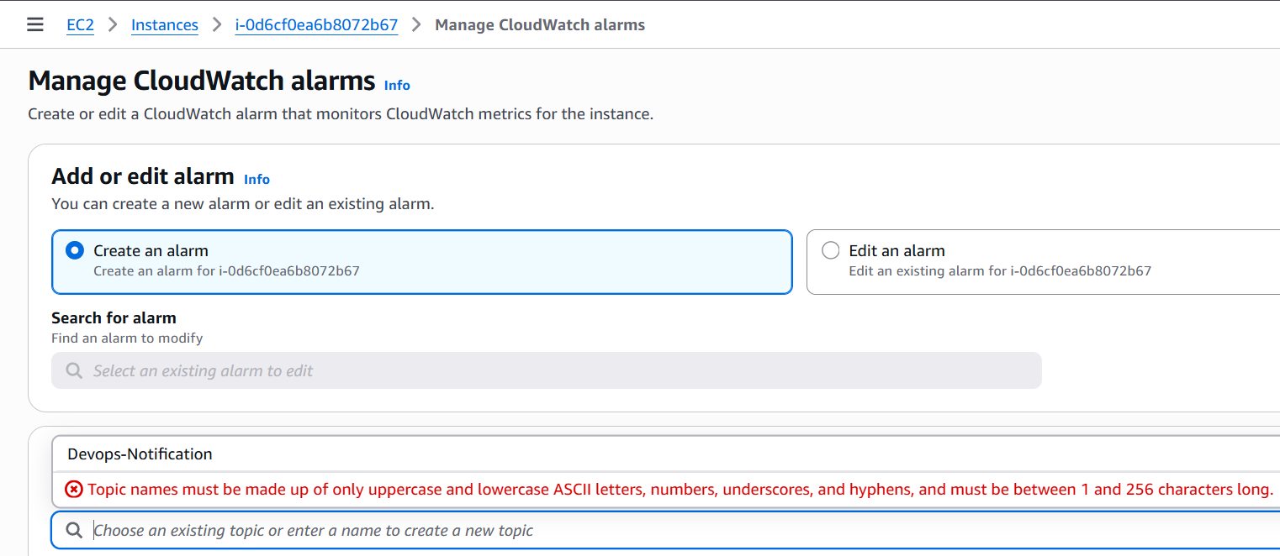

Go to SNS – create topic – standard—Name of topic – create.

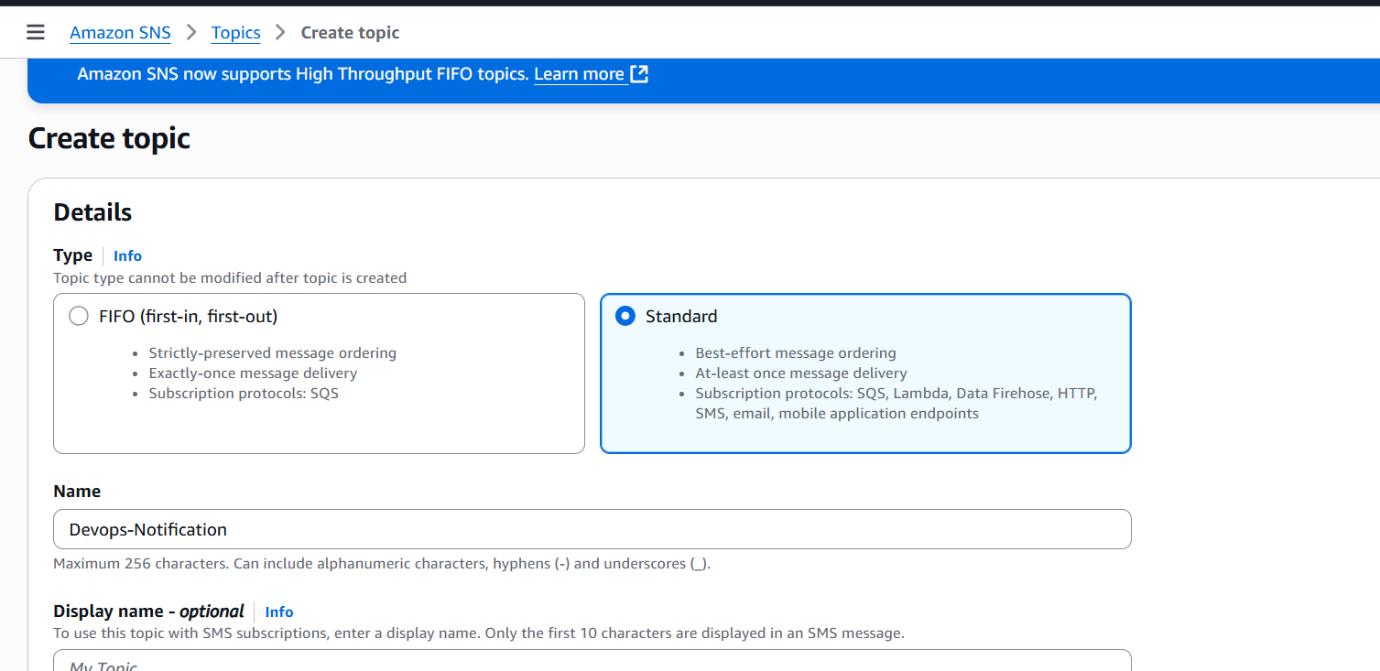

Now make a subscription for topic. Once you save your email or sms, you will receive notification.

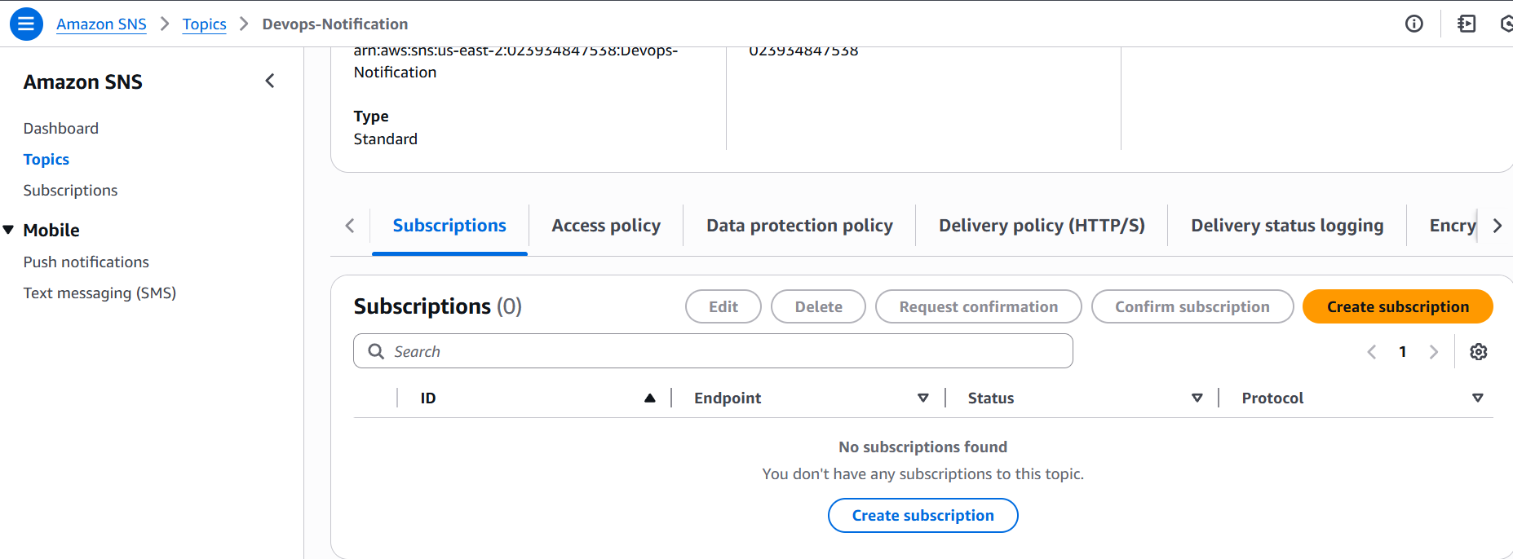

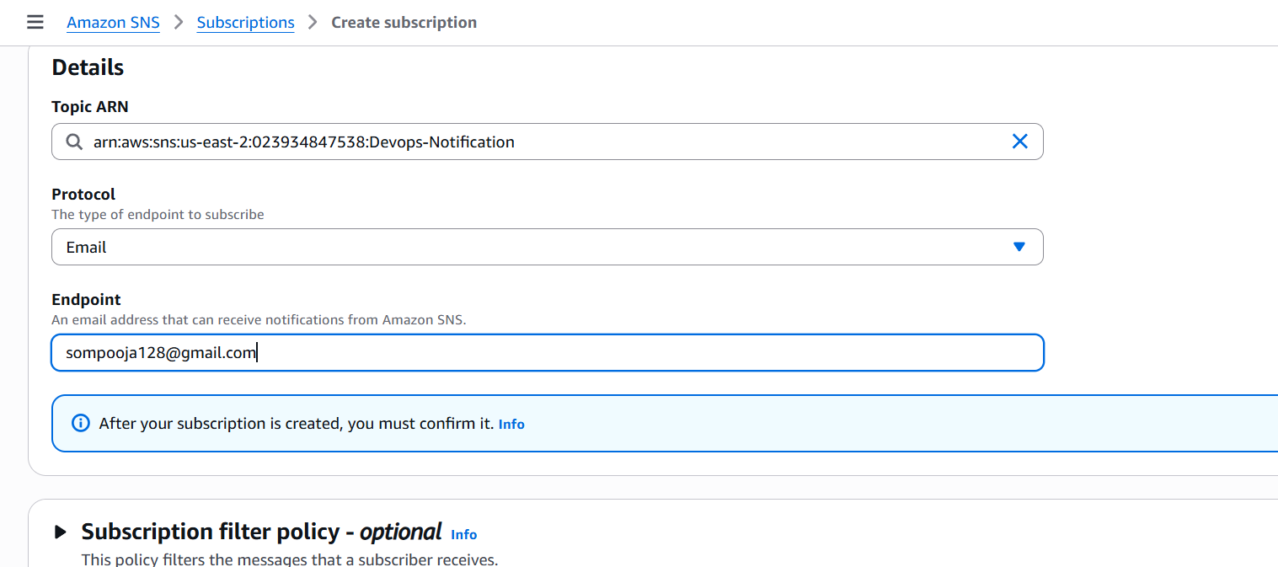

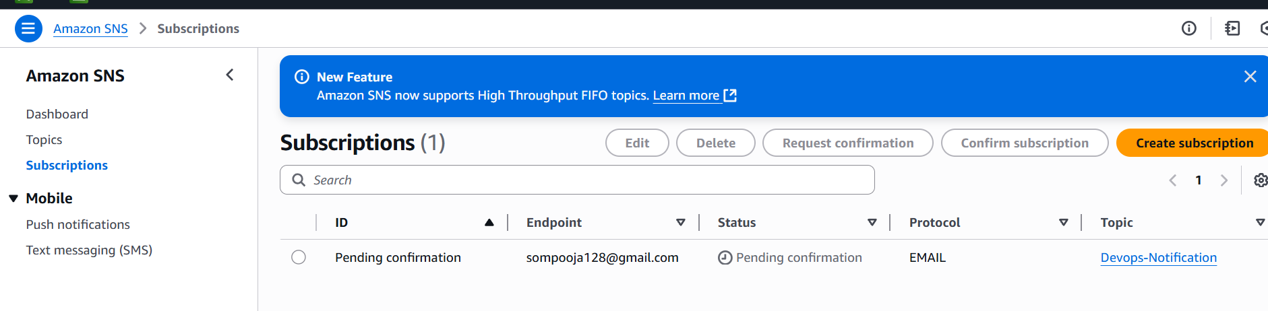

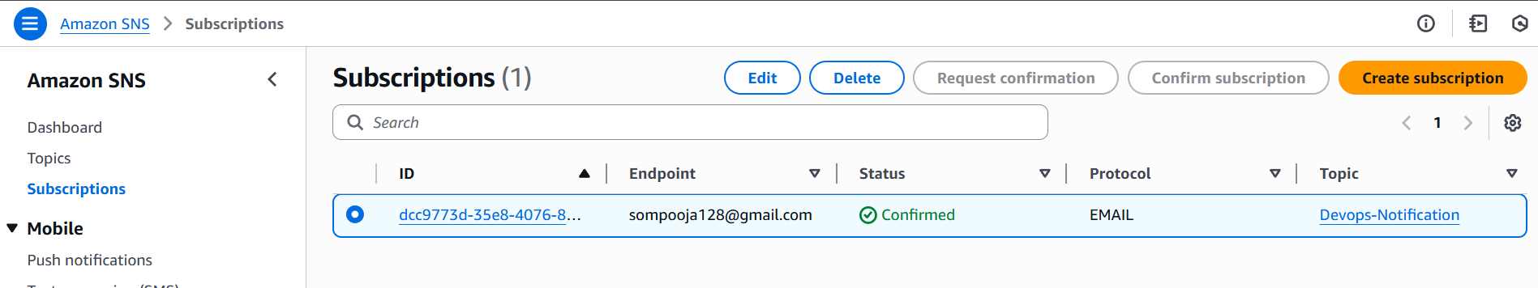

Again come to your EC2 Alarm and select alarm notification – enter CPU Threshold –create.

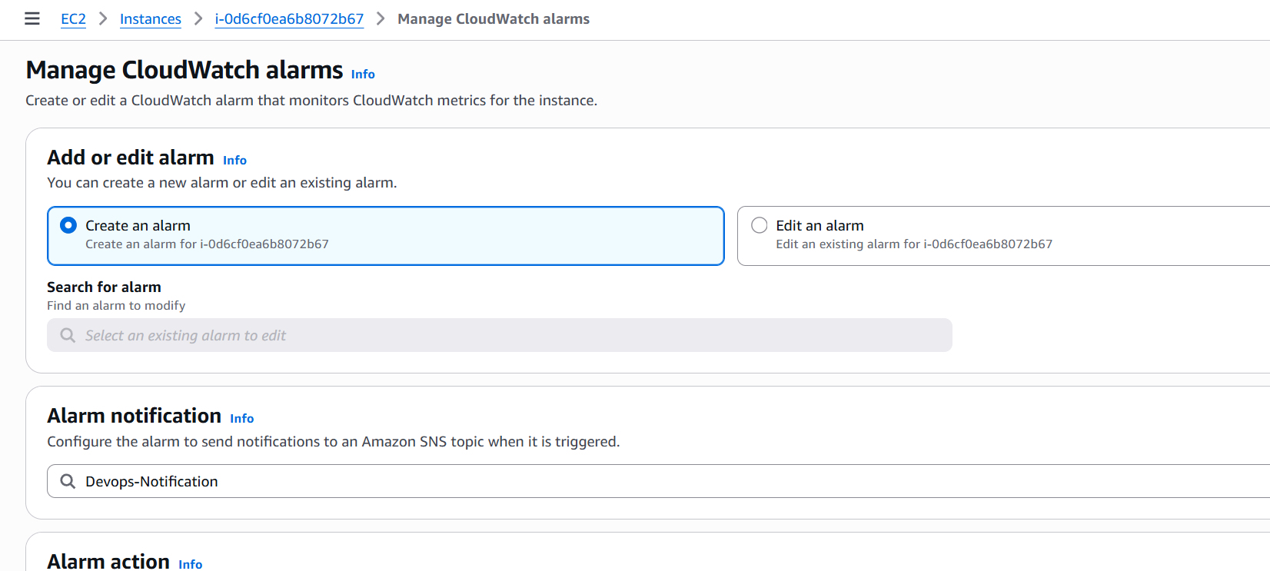

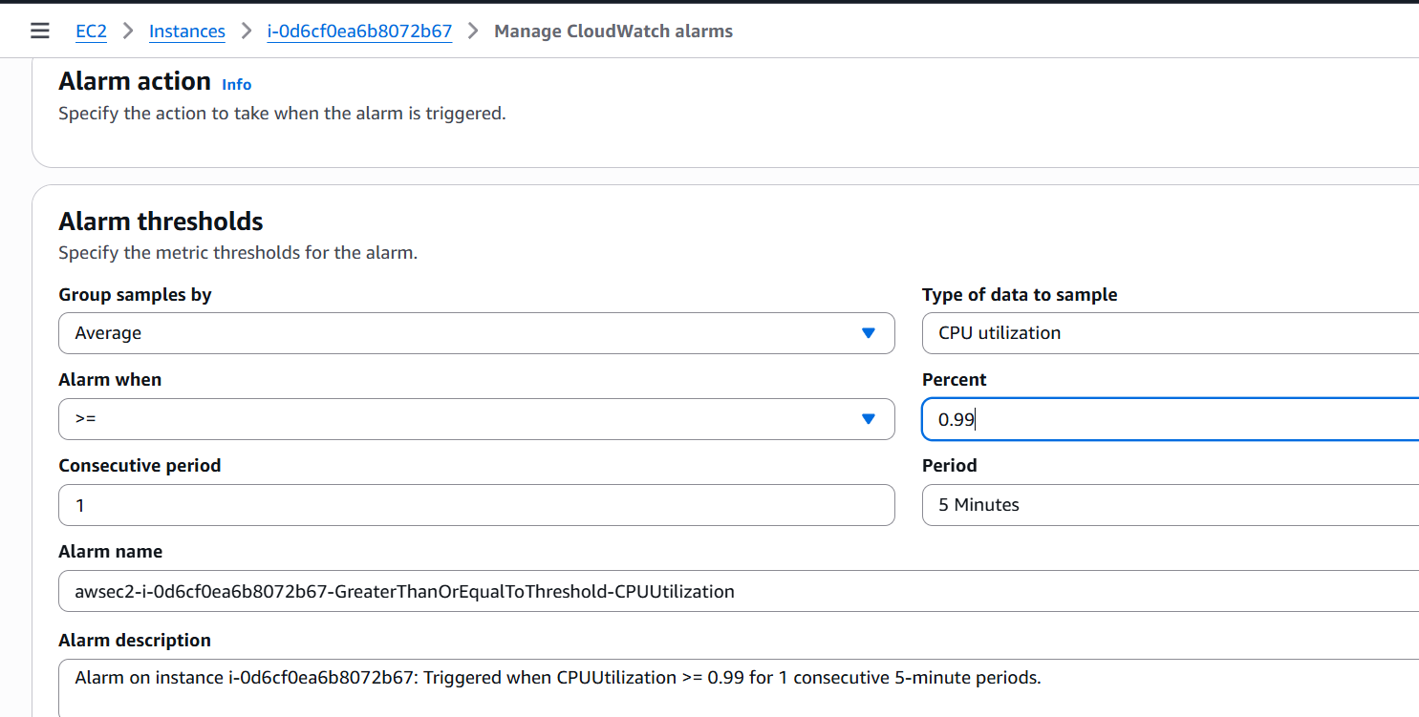

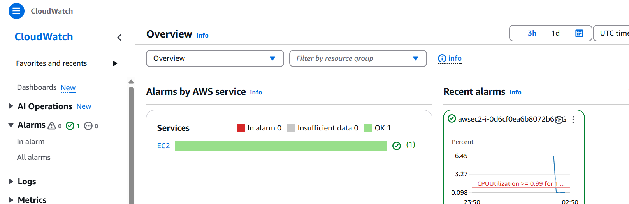

Manually increase stress and monitor the CPU utilization, once it cross threshold you will receive email.

